**Physics 30 – Lesson 24**

**Electromagnetic Waves**

/ 69

1)

A) The source of all electromagnetic radiation is **accelerating charges**.

/4 B) 

C) 

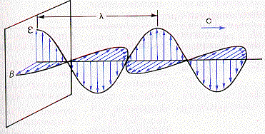 D)

2) All of them have electric fields and magnetic field vibrating perpendicular to each

/2 other that radiate through space. Hence ­– electromagnetic radiation.

3)

A) AC power, radio, radar, TV, microwaves

/4 B) Infrared, visible light, UV light

C) X-rays

D) Gamma rays

4) Radio waves and visible light waves are similar in that both are electromagnetic

/2 radiation with the same speed. They have different frequencies and wavelengths.

5) x-rays and visible light waves are similar in that both are electromagnetic

/2 radiation with the same speed. They have different frequencies and wavelengths.

6) As the frequency of waves increases the wavelength *decreases*. The range of

/3 wavelengths for visible light from *375nm* to *750nm*. Which type of wave would penetrate the human body more easily, X-rays or 

7) The polar water molecules in food have a natural frequency of vibration in the

/3 microwave range of the electromagnetic spectrum. The oscillating electric field of microwaves cause the water molecules to vibrate. Increased vibration = increased heat. Another application for microwaves is telecommunications across the country.

8) Due to the heat of our bodies we continually radiate infrared radiation which can

/1 be detected in the “dark”.

9) Honey bees see light in the ultra violet part of the spectrum that human eyes are

/1 incapable of seeing.

10) X-rays penetrate soft tissue and are stopped by bones and hard tissue. An x ray

/2 photo is the x-ray shadow of a bone.

11) North – south.

/1

12) 

/8



36000 km

6000 km

3000 km

13)

/3

14)



/3

15)

/3

16) The period and frequency do not change when speed and wavelength change.



/3

17)

/3

18) 



/6

19)



/6



20)

/6

these are microwaves

21)

a) The source of all electromagnetic radiation is an accelerating charged particle.

b) Electromagnetic radiation having a frequency of 1.0 x 1015 Hz would be classified as ultra violet radiation.

c) When an electromagnetic wave passes from one material into another with a higher index of refraction, its frequency will not change.

/3